* **Activity 7:**

### Illegal Queries Using Group Functions

1. **Demonstrating an Error**

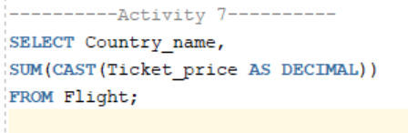

Output:

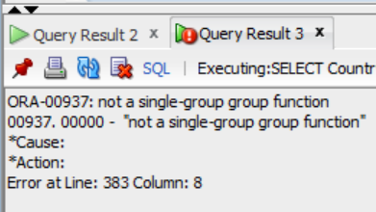

1. **Removing the error:**

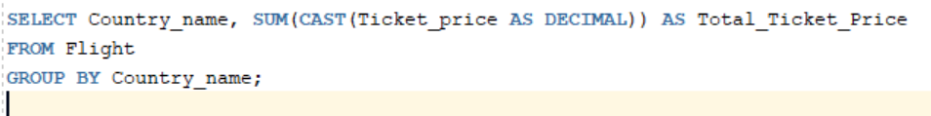

Output:

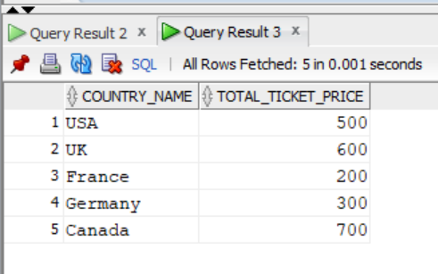

1. **Another demonstration of Error**

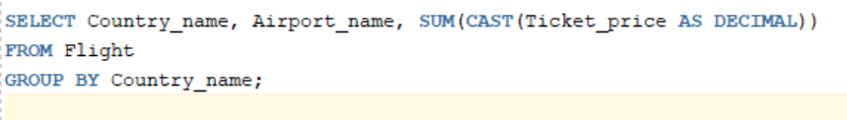

**Output:**

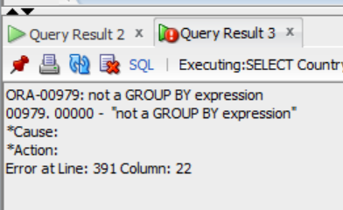

1. **Removing the error**

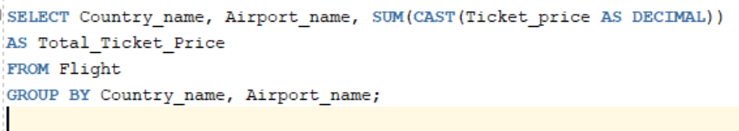

**Output:**

